**Steps:**

# Download terraform

To install Terraform, First Download the Terraform Cli Utility for windows from terraforms official website

Select the Operating System Windows followed by either 32-bit or 64-bit based on your OS type.

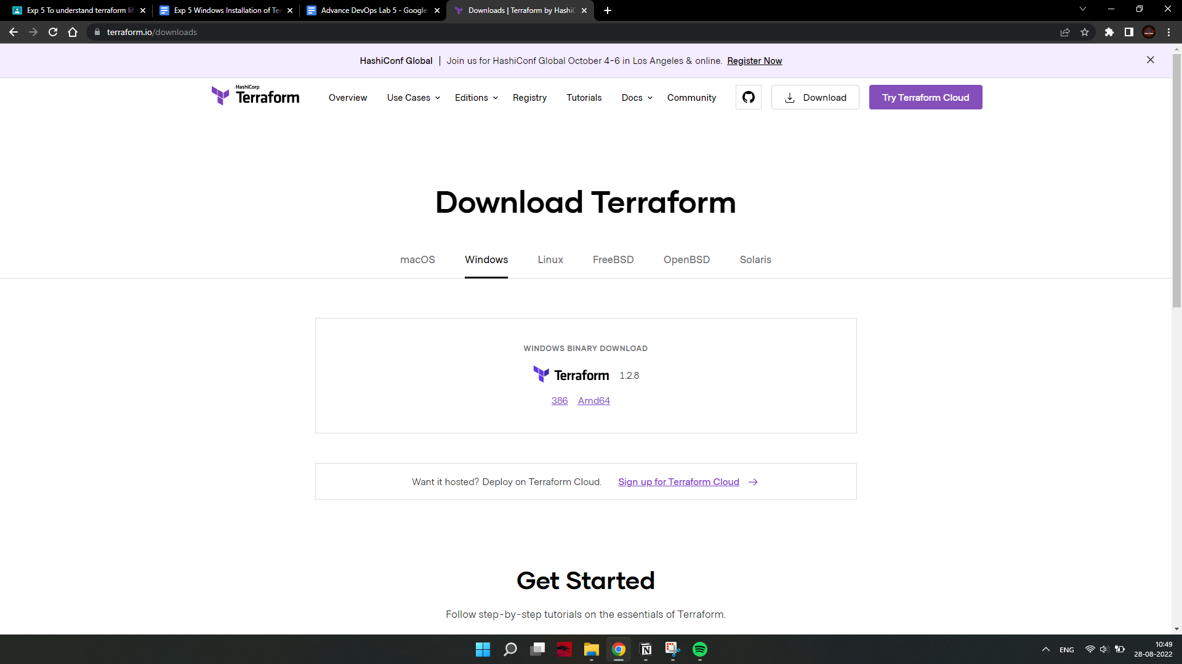

1. Extract the downloaded setup file Terraform.exe in the C:\Terraform directory.

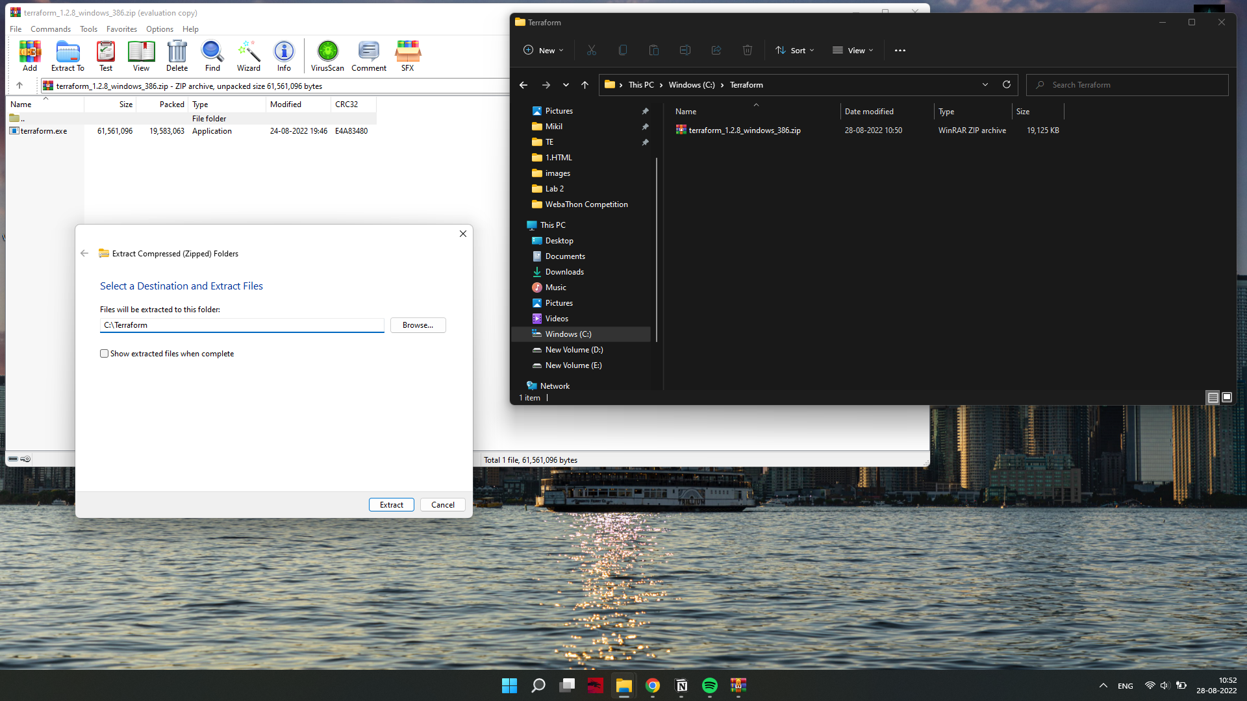

1. Set the System path for Terraform in Environment Variables

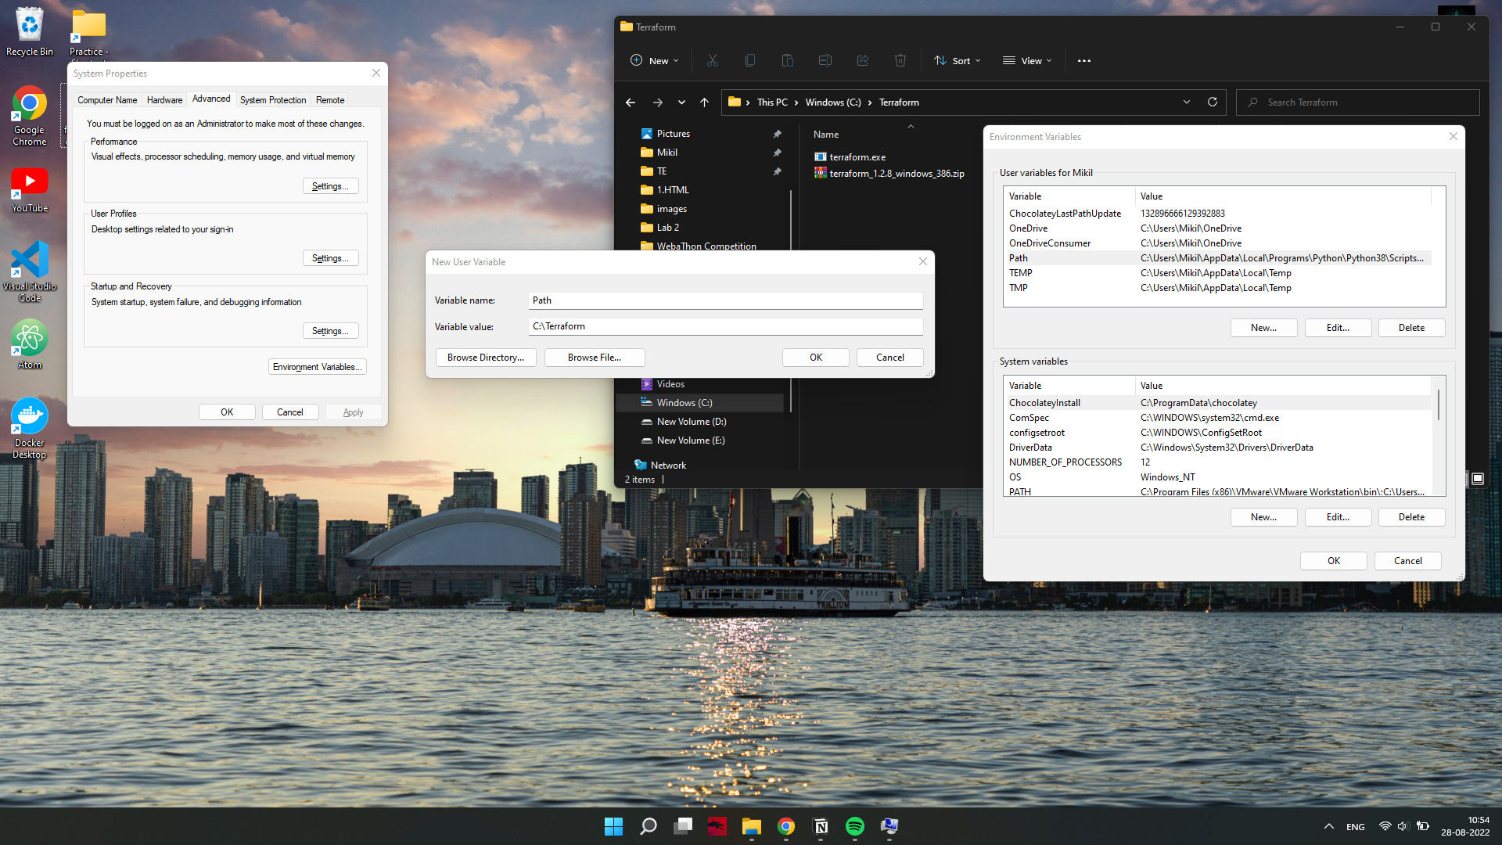

# Open PowerShell with Admin Access.

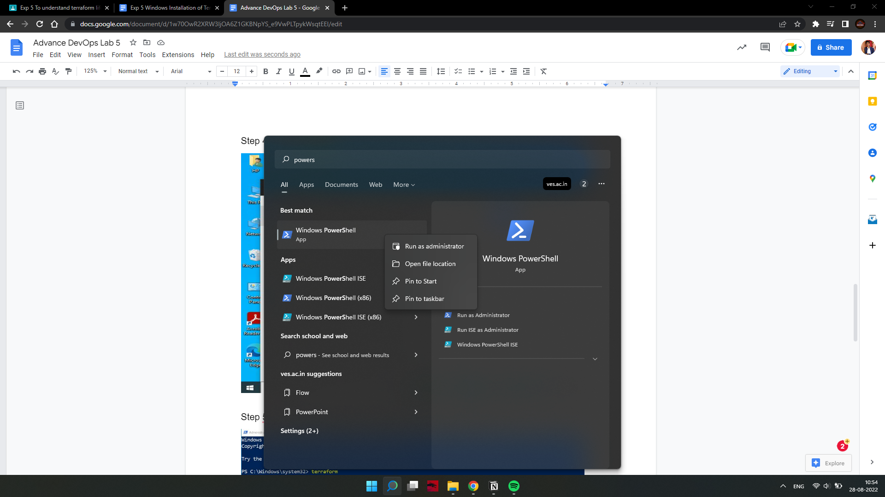

1. Open Terraform in PowerShell and check its functionality.

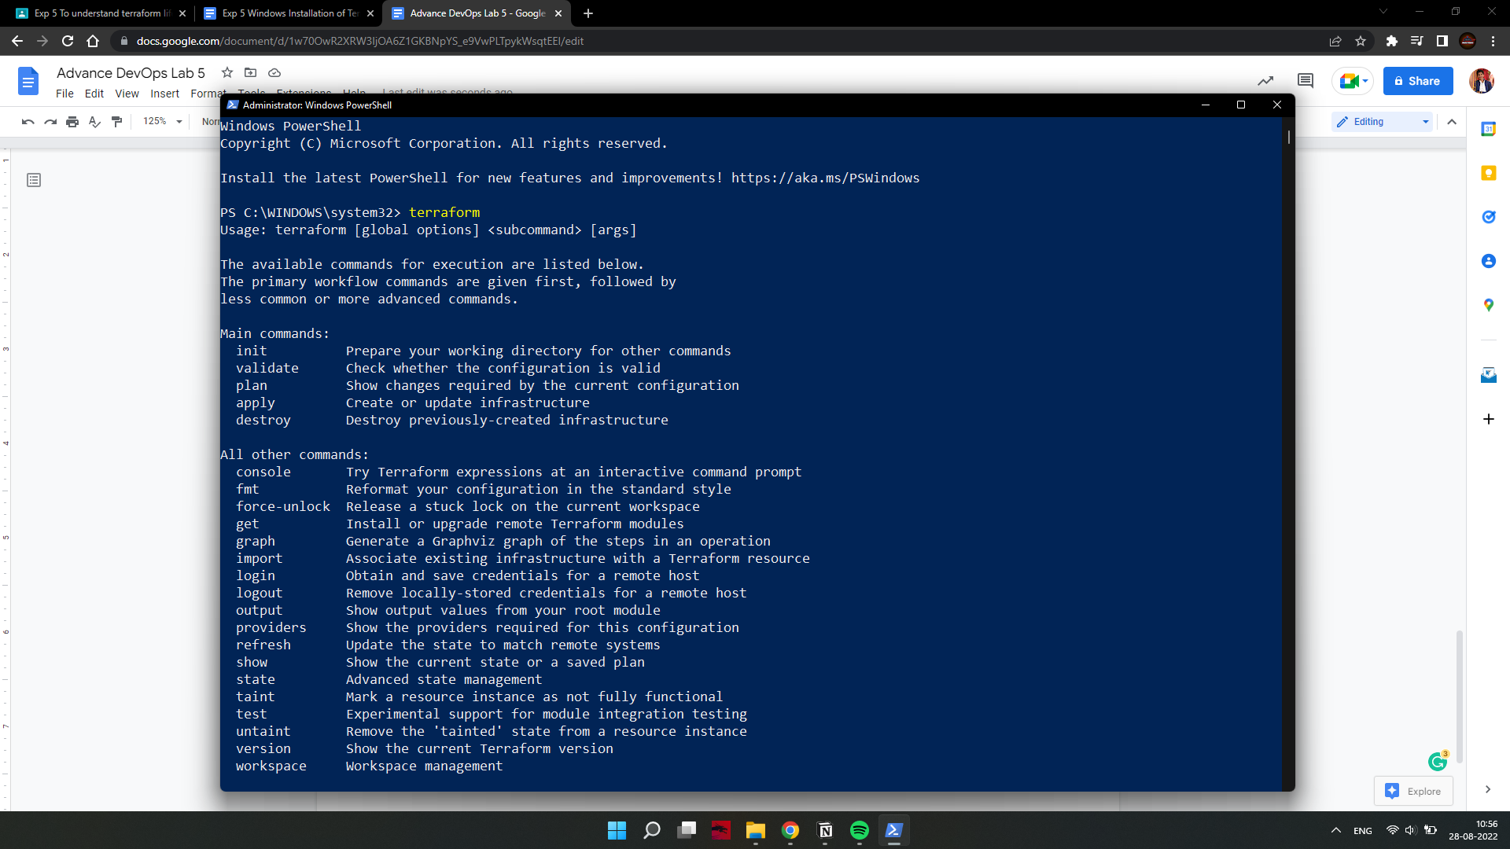

**Note: If any error comes, then please recheck or set the path of Terraform in the Environment variable again.**